XPLORA INNOVATHON 2026

TOPIC:
TokenEats
INSTITUTE: XIM UNIVERSITY
GROUP NO.: 14
GROUP NAME: Team CodeBlooded
TEAM MEMBERS:
Saishreya Mohanty
Hemangini Behera
Pritisha Sarangi
Jitisha Behera

ABSTRACT

In many colleges and hostels, mess management is still handled using traditional manual systems, which often lead to overcrowding, long waiting queues, food wastage, and lack of proper monitoring. During peak hours, students struggle with excessive waiting time, while kitchen staff face difficulty in estimating food demand accurately. This inefficiency leads to unnecessary resource wastage and operational challenges.

TokenEats is a smart digital token-based mess management system designed to manage food distribution and reduce chaos during meal hours. The system allows students to generate digital tokens in advance through a web application. Each token is validated using a QR code at the serving counter, ensuring a smooth and organized flow of students. The platform also provides real-time tracking of meal availability and, helping mess authorities prepare food based on actual demand.

The proposed solution is developed using modern web technologies such as React for the frontend interface, a backend framework like Flask/Node.js for server-side logic, and a database system for secure data management. By integrating digital tokenization and real-time monitoring, TokenEats minimizes waiting time, reduces food wastage, and enhances operational efficiency.

INTRODUCTION

1. Background of Mess Management Systems

Mess management systems play a crucial role in hostels, universities, and residential institutions where a large number of students depend on centralized food services every day. Traditionally, mess operations have been managed manually, where food preparation is based on approximate attendance and students gather during fixed meal timings. In most institutions, entry is regulated either through ID cards, physical tokens, or simple manual checking by staff.

Over the years, while academic institutions have adopted digital systems for attendance, examinations, and communication, mess management has largely remained conventional. The growing number of students in universities has increased the complexity of handling meal distribution efficiently. As a result, managing food quantity, reducing waste, and ensuring smooth service has become more challenging.

2. Problems in Traditional Mess Operations

In a typical hostel scenario, meal timings are fixed, and a large number of students arrive at the mess at the same time, especially after classes or during peak hours. This leads to long queues, overcrowding, and frustration among students. Many students often skip meals simply to avoid standing in long lines.

Another major issue is inaccurate estimation of food demand. Since food preparation is usually based on rough assumptions rather than actual data, it often results in either shortage or excess food. Shortage causes inconvenience and dissatisfaction, while excess food leads to wastage and financial loss. In addition, manual verification systems lack transparency and real-time tracking, making it difficult for authorities to monitor attendance patterns and meal consumption trends.

From the staff’s perspective, handling crowd control during rush hours is stressful and inefficient. There is no structured mechanism to regulate the flow of students, which further complicates operations.

3. Need for Digital & Smart Systems

With the increasing number of students in hostels and universities, traditional mess systems are no longer efficient. There is a clear need for a digital solution that can manage meal distribution in a more organized and data-driven manner. A smart token-based system can help regulate crowd flow, reduce waiting time, and allow food preparation based on actual demand.

By using technologies such as QR code verification and real-time tracking, institutions can minimize food wastage and improve overall operational efficiency. Implementing a digital mess management system is therefore essential to create a smoother, more transparent, and sustainable dining experience for students.

PROBLEM STATEMENT

&

OBJECTIVE

Problem Statement:

University mess halls rely on manual and physical token systems to manage food distribution, which leads to long waiting queues, lack of transparency, and operational inefficiency during peak hours. Students have no real-time visibility into menu availability, counter load, or expected wait time before reaching the mess, resulting in time wastage and frustration. Simultaneously, mess staff struggle with demand prediction and token tracking, causing food wastage, shortages, and errors in service. There is a clear need for a smart, digital, and scalable system that streamlines queue management, improves visibility for students, and optimizes mess operations in real time.

Objectives:
The primary objectives of the proposed TokenEats system are:
- To reduce student waiting time during peak meal hours.
- To regulate and control crowd flow within the mess premises.
- To optimize food preparation based on real-time token generation data.
- To improve hygiene by minimizing physical contact and manual verification.
- To provide analytical insights and reports for better decision-making and resource management.

KEY FEATURES OF TokenEats

1. Digital Token Generation
Students can generate meal tokens online before the meal time, reducing the need to stand in long queues. This allows better planning for both students and mess staff.

2. QR Code-Based Validation
Each token is uniquely generated and verified using QR scanning at the entry point. This ensures secure authentication and prevents misuse or duplication.

3. Real-Time Monitoring Dashboard
Mess administrators can monitor attendance, token usage, and meal statistics through a centralized dashboard. This enables data-driven decision-making.

4. Demand-Based Food Preparation
Since the system records the exact number of tokens generated, food preparation can be aligned with actual demand, minimizing wastage and improving efficiency.

5. Organized Crowd Management
By regulating token generation and validating entry digitally, crowd flow during peak hours becomes more structured and controlled.

PROPOSED SYSTEM:

TokenEats

The proposed system, TokenEats, is a smart digital mess management platform designed to streamline meal distribution and eliminate the inefficiencies of traditional systems. The core idea of TokenEats is to replace manual queues and physical tokens with a secure, web-based digital token system integrated with QR code verification and real-time monitoring.

In this system, students can log in to the web application using their registered credentials and generate a digital token for a specific meal in advance. Each generated token contains a unique QR code that is scanned at the mess counter during entry. Once scanned, the system validates the token and updates the database in real time, ensuring that each token is used only once.

The platform also provides a live dashboard for mess authorities. This dashboard displays the total number of tokens generated for each meal, helping kitchen staff prepare food according to actual demand instead of rough estimates. As a result, food wastage is significantly reduced, and shortages can be avoided.

.

SYSTEM ARCHITECTURE:

The TokenEats system follows a three-tier architecture consisting of the Frontend (User Interface), Backend (Server Logic), and Database (Data Storage). This structure ensures smooth communication between users and the system while maintaining data security and efficiency.
The architecture is designed to handle multiple users simultaneously and provide real-time updates for both students and mess administrators.
- Frontend Layer (Client Side)
The frontend is the user interface of the system, where students and administrators interact with the platform. It is developed using modern web technologies such as React / HTML / CSS / JavaScript.
Functions of Frontend:
- Student login and authentication
- Digital token generation
- QR code display
- Admin dashboard view
- Meal statistics display
The frontend sends user requests (such as token generation) to the backend through API calls.

- Backend Layer (Server Side)
The backend handles the core logic of the application. It is developed using a framework such as Flask / Node.js.
Functions of Backend:
- User authentication and authorization
- Token creation and validation
- QR code generation
- Real-time data processing
- API handling between frontend and database
When a student generates a token, the backend verifies eligibility, creates a unique token ID, generates a QR code, and stores the information in the database.
- Database Layer
The database stores all system-related data securely. It may use MySQL / Firebase / MongoDB depending on implementation.
Data Stored:
- Student details
- Token records
- Meal timings
- Token usage status
- Attendance logs

Data Flow
Students/Admin (User)
↓
Frontend (Web Application)
↓ API Calls
Backend (Server)
↓
Database (Storage)

Data Flow Explanation
1) User logs in through the frontend.
2) Frontend sends login request to backend.
3) Backend verifies credentials from database.
4) Student generates token → backend creates unique token & QR code.
5) QR scanned at mess → backend validates token.
6) Database updates token status as “Used”.
7) Admin dashboard reflects real-time updates.

WORKFLOW:
The TokenEats system follows a structured workflow to ensure smooth meal distribution and efficient crowd management. The methodology focuses on secure authentication, controlled token generation, QR-based validation, and real-time data updates.
The entire process is designed to minimize waiting time, prevent token misuse, and provide accurate demand estimation for food preparation.
Step-by-Step Workflow
Step 1: User Registration & Login
Students register using their institutional credentials. After successful registration, they log in securely to access the system.
Step 2: Meal Selection
The student selects the desired meal (Breakfast, Lunch, or Dinner) within the allowed time window.
Step 3: Digital Token Generation
Upon selection, the system verifies eligibility and generates a unique digital token. A QR code is automatically created and displayed to the student.
Step 4: Database Storage
The generated token details are stored in the database with a unique ID and status marked as “Active”.
Step 5: QR Code Verification at Mess
At the mess entrance, the QR code is scanned. The backend verifies the token in real time.
If valid → Entry allowed, token status updated to “Used”.
If invalid or already used → Entry denied.
Step 6: Real-Time Dashboard Update
The admin dashboard updates automatically, showing:
- Number of tokens generated
- Number of tokens used
- Remaining expected students

Step 7: Demand-Based Food Preparation
Based on the total tokens generated, kitchen staff prepare food accordingly, reducing wastage and shortages.
Methodology Approach
The development methodology follows a modular approach:
- Requirement Analysis – Identifying mess management problems.
- System Design – Designing architecture and database schema.
- Implementation – Developing frontend, backend, and integration.
- Testing – Validating token generation, QR scanning, and database updates.
- Deployment – Hosting system for institutional use.
This structured workflow ensures reliability, security, and scalability of the TokenEats platform

Flowchart
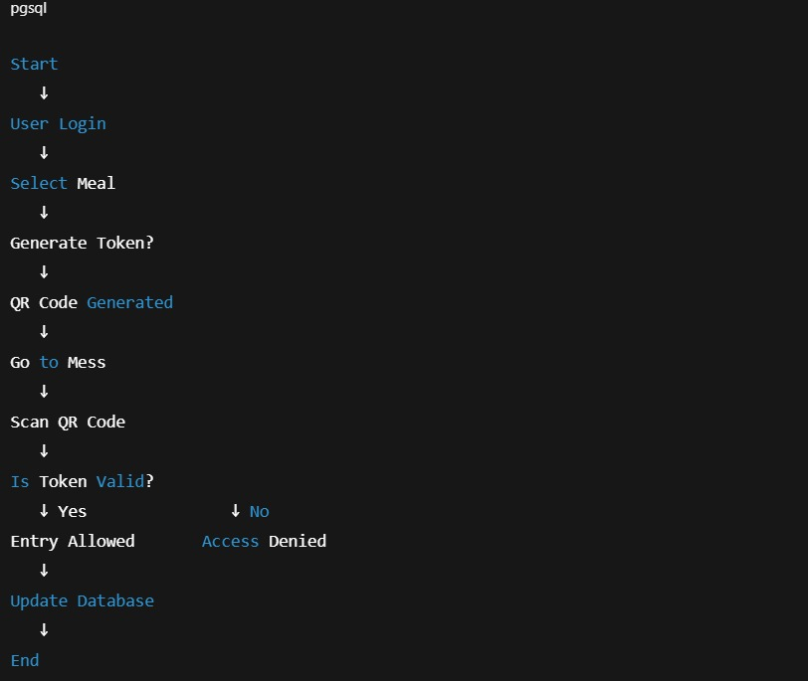

TECHNOLOGY STACK:
Frontend Technologies
React.js / HTML / CSS / JavaScript
The frontend is developed using React.js to create a responsive and interactive user interface. React allows component-based development, making the system modular and easy to maintain. CSS ensures proper styling, while JavaScript manages client-side logic and API communication.
Reason for Selection:
React provides faster rendering through virtual DOM and enhances user experience with dynamic content updates.
Backend Technologies
Node.js / Flask (Python-based Framework)
The backend is responsible for handling business logic, token generation, authentication, and QR validation. Node.js (or Flask) ensures efficient request handling and supports RESTful API integration between frontend and database.
Reason for Selection:
These frameworks are lightweight, scalable, and suitable for real-time applications.

Database
MySQL / MongoDB / Firebase
The database stores user credentials, token records, meal information, and usage logs. It ensures that each token is uniquely identified and cannot be reused.

Reason for Selection:
Relational databases like MySQL provide structured storage and strong data integrity, while NoSQL options like Firebase allow real-time synchronization.

Additional Tools & Technologies
- QR Code Generator Library – For generating unique QR codes for each token.
- QR Scanner Integration – For verifying tokens at the mess counter.
- REST APIs – For communication between frontend and backend.
- Hosting Platform (e.g., Firebase / Render / Local Server) – For deployment.

IMPLEMENTATION

DETAILS:
The implementation of TokenEats is divided into modules for better organization and maintainability.
1. Authentication Module
- Handles student registration and login.
- Verifies credentials securely.
- Prevents unauthorized access.

2. Token Management Module
- Generates unique token ID.
- Creates corresponding QR code.
- Stores token details in database.
- Updates token status after use.

3. QR Validation Module
- Scans QR code at mess entry.
- Matches token ID with database record.
- Checks validity and usage status.
- Updates status to “Used” after successful verification.

4. Admin Dashboard Module
- Displays number of tokens generated per meal.
- Shows real-time attendance.
- Provides analytical reports.
- Helps estimate food demand accurately.
- Security Measures Implemented
- Unique token ID generation.
- One-time QR validation system.
- Secure login authentication.
- Database integrity constraints.

RESULTS, OUTPUTS

&

SYSTEM SCREENS:
The TokenEats system was successfully designed and implemented as a functional prototype. The system demonstrates effective digital token generation, QR-based validation, and real-time data monitoring. The results indicate a significant improvement in crowd management, operational efficiency, and food wastage reduction compared to traditional methods.
1. System Outputs
The following outputs are generated by the system:
- Landing page
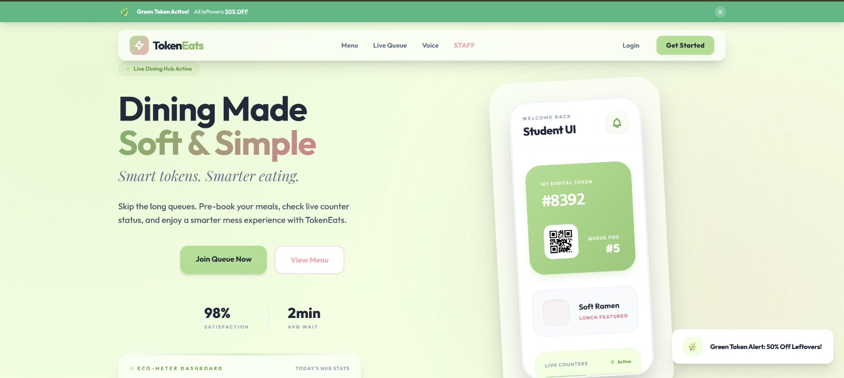

- Eco-Meter Dashboard
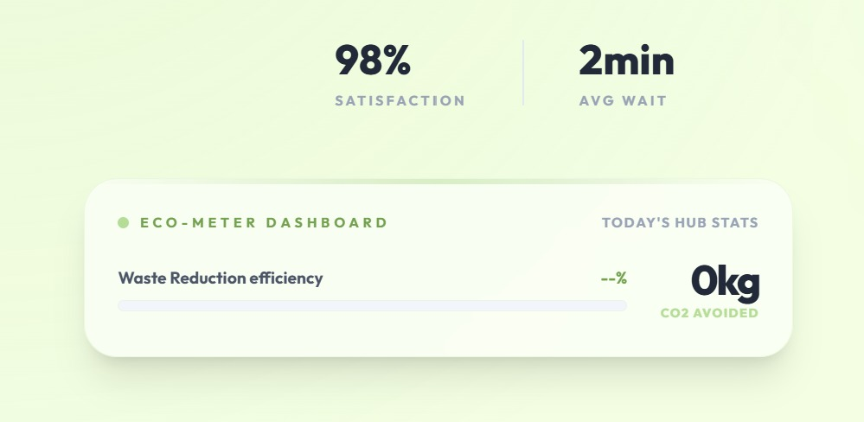

- Monthly Mess Menu
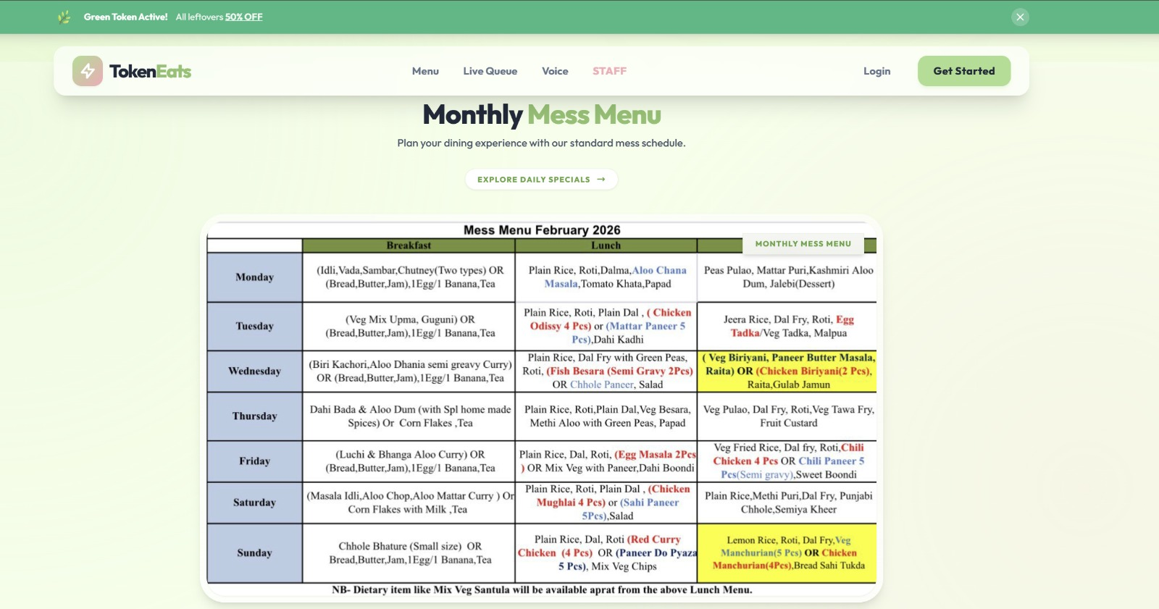

- How it works
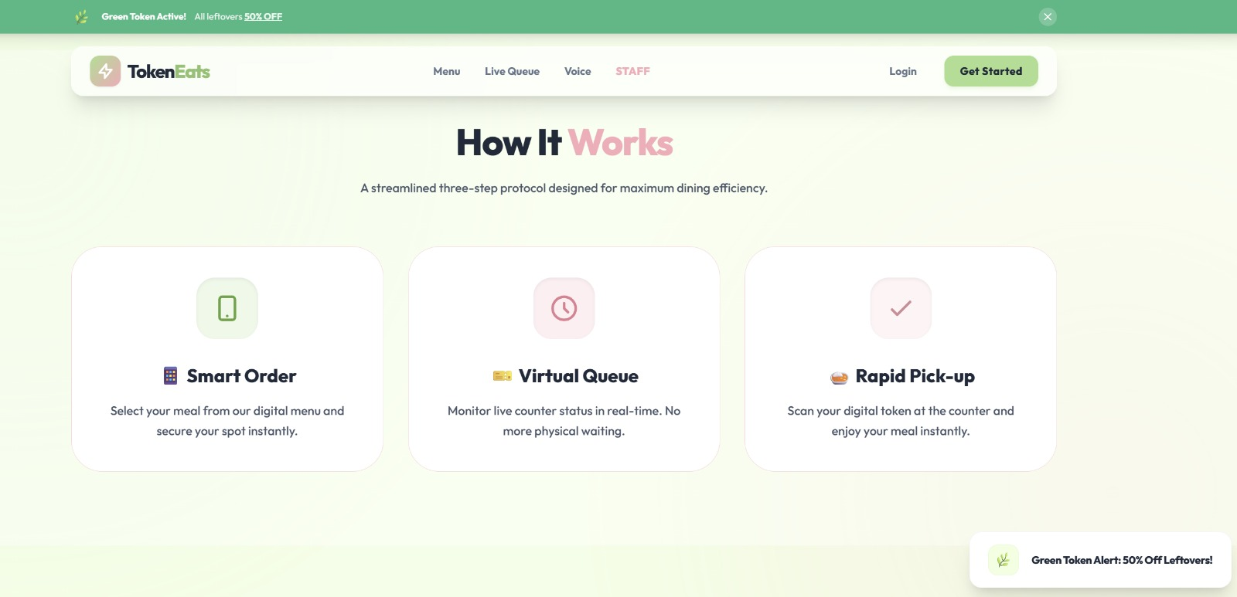

- Daily Menu
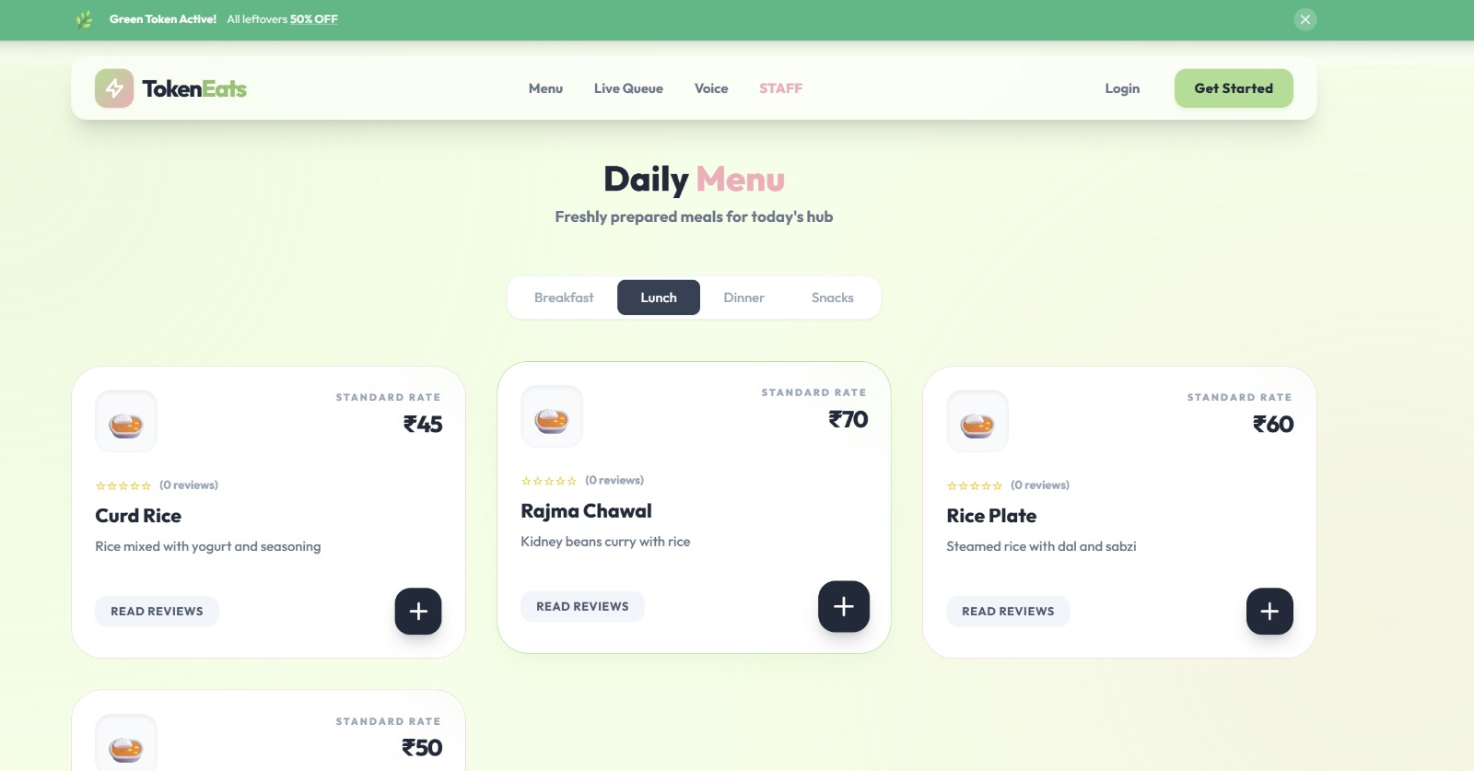

- Food Order
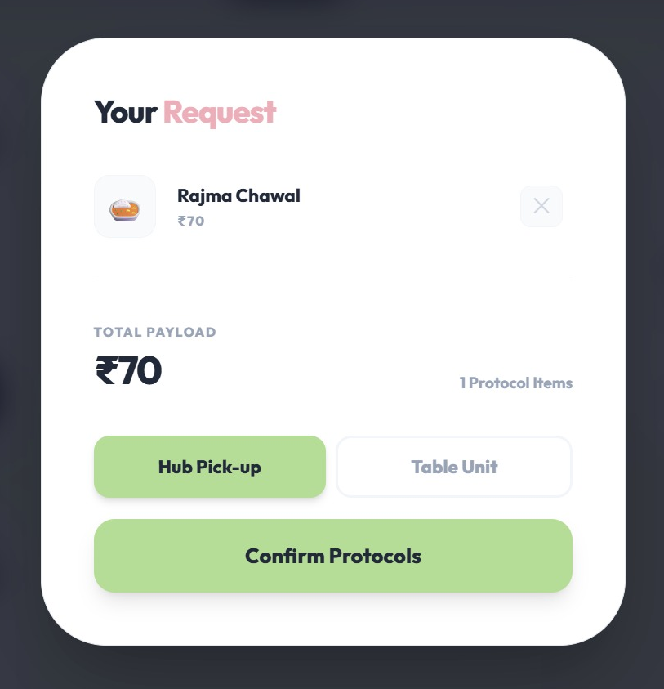
- Login

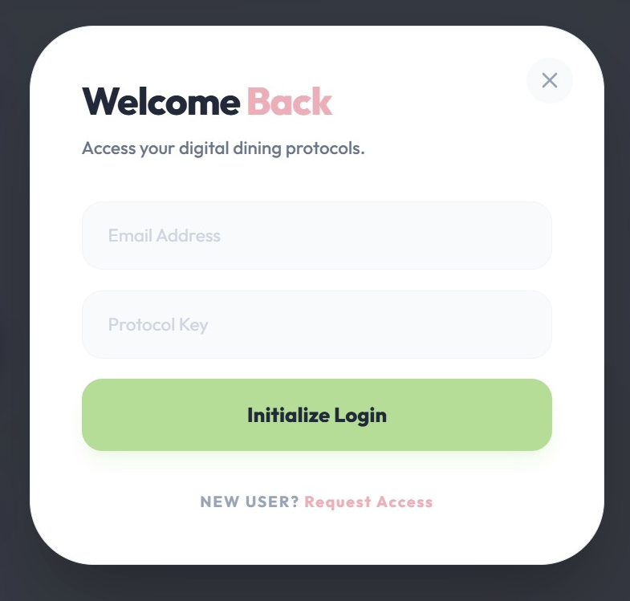
- Join Hub
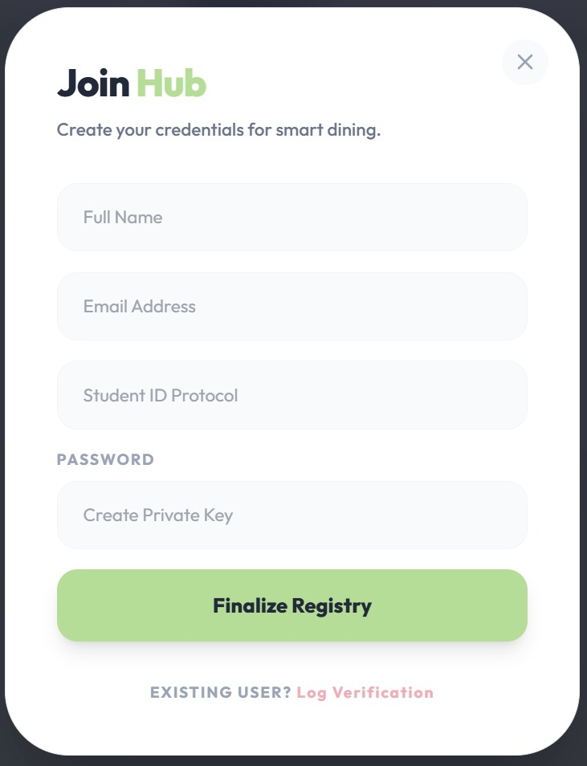
- User Role
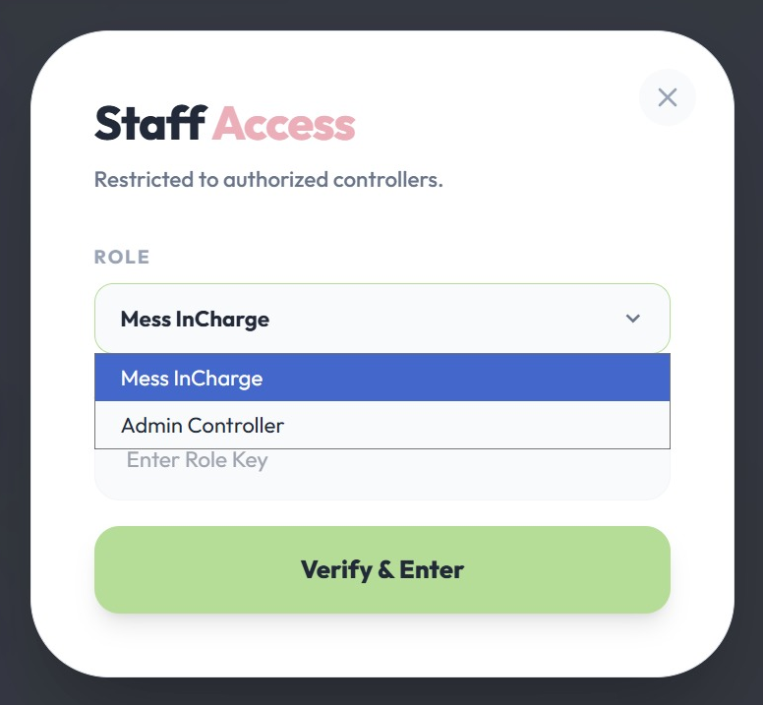

- Receipt
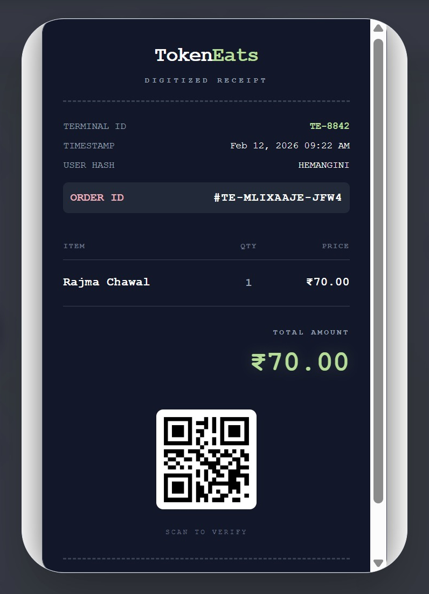

- Live Counters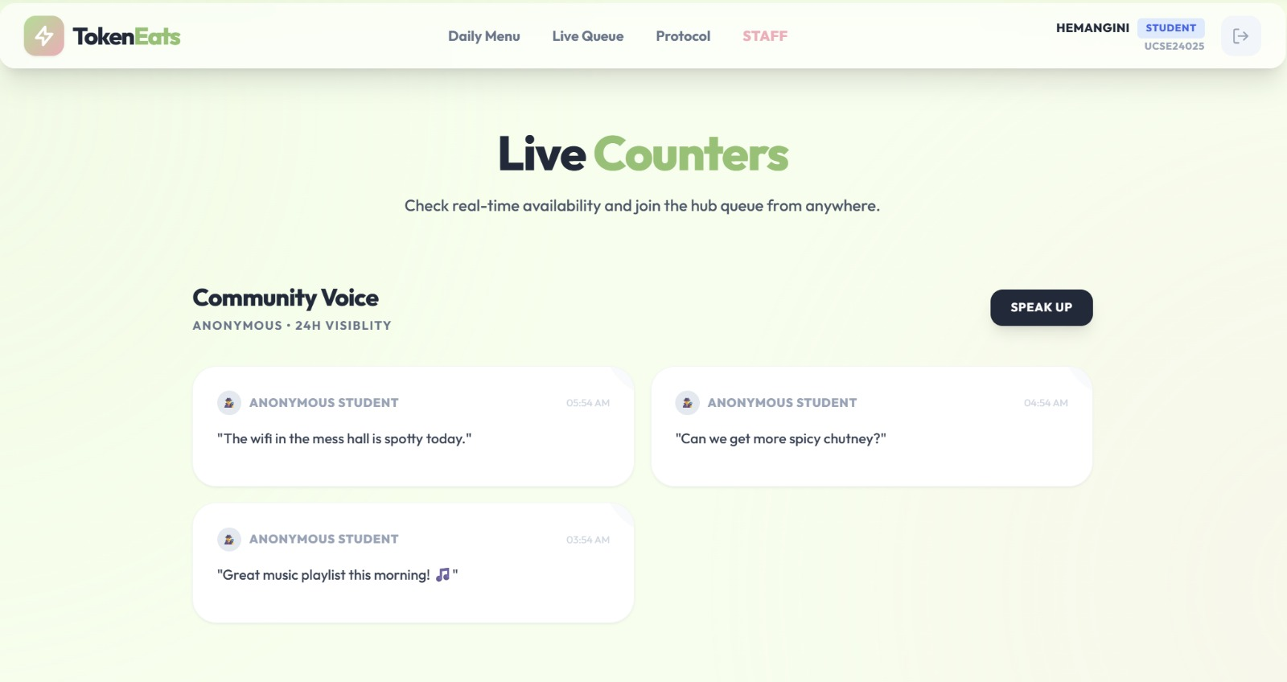
- Community Voice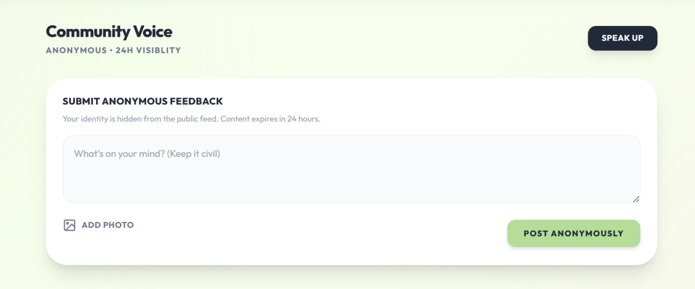

- Green Token Deals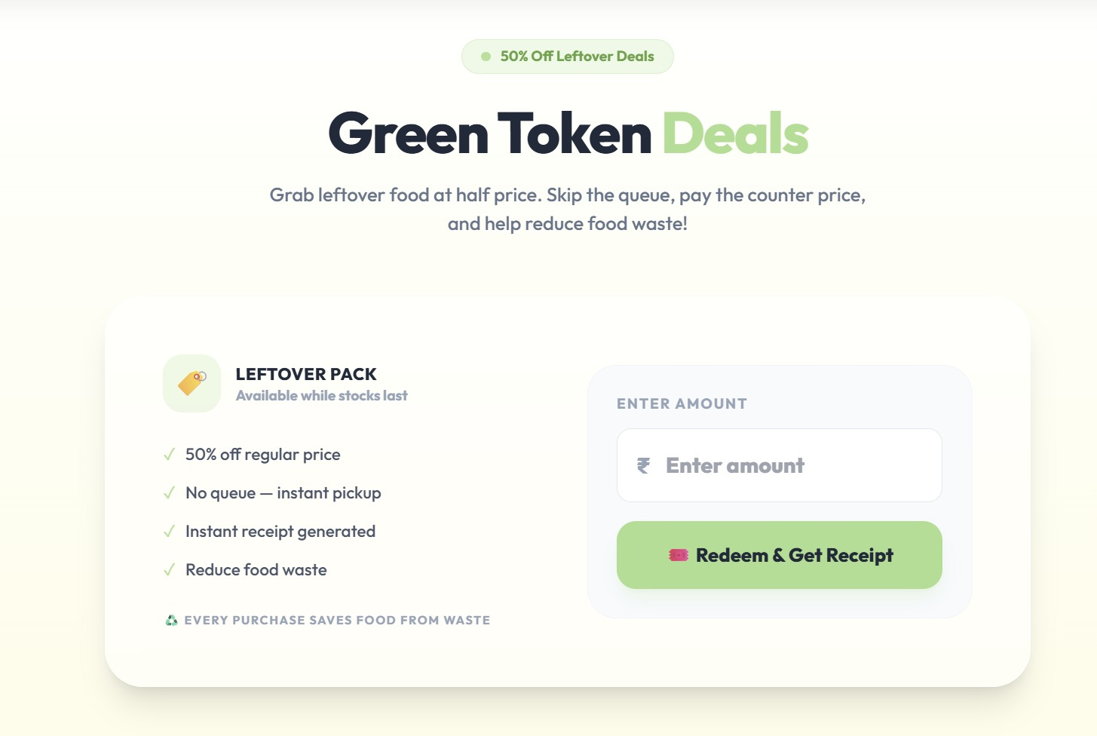

- Counters

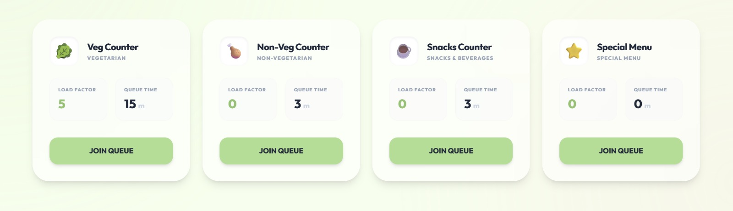

- Digital Token Generation Output

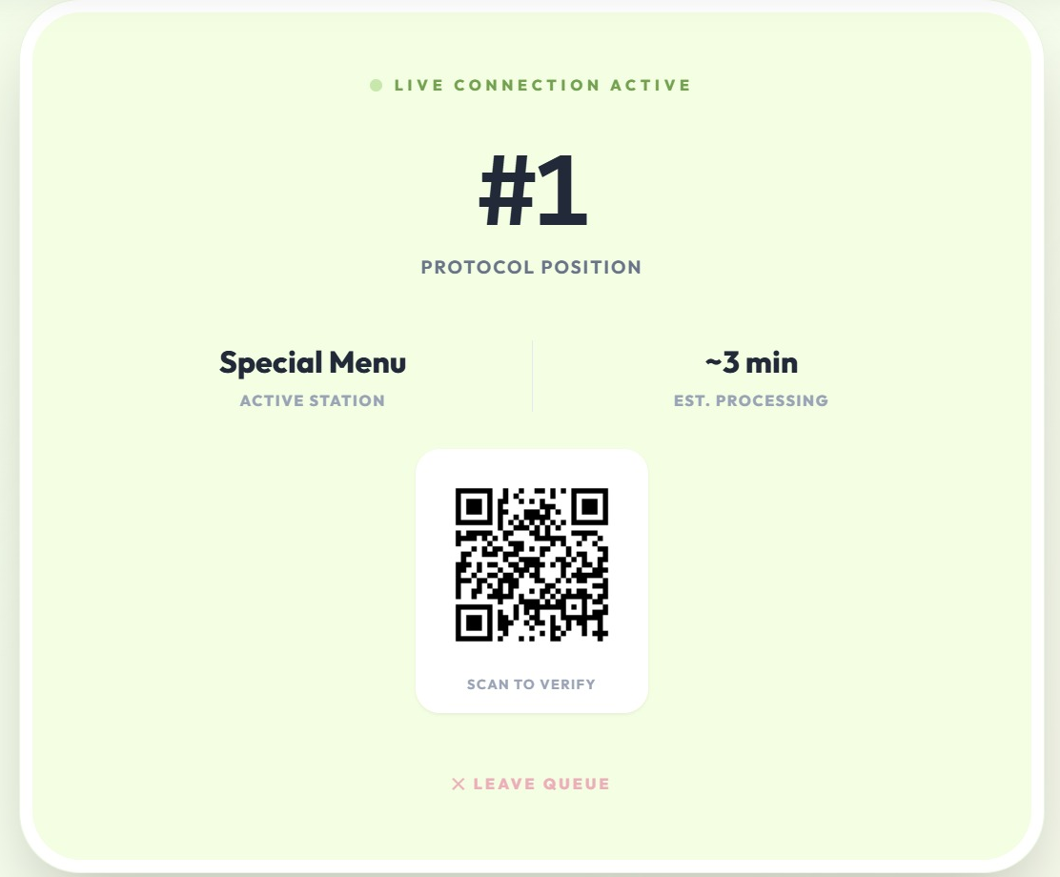

- Talk to Us
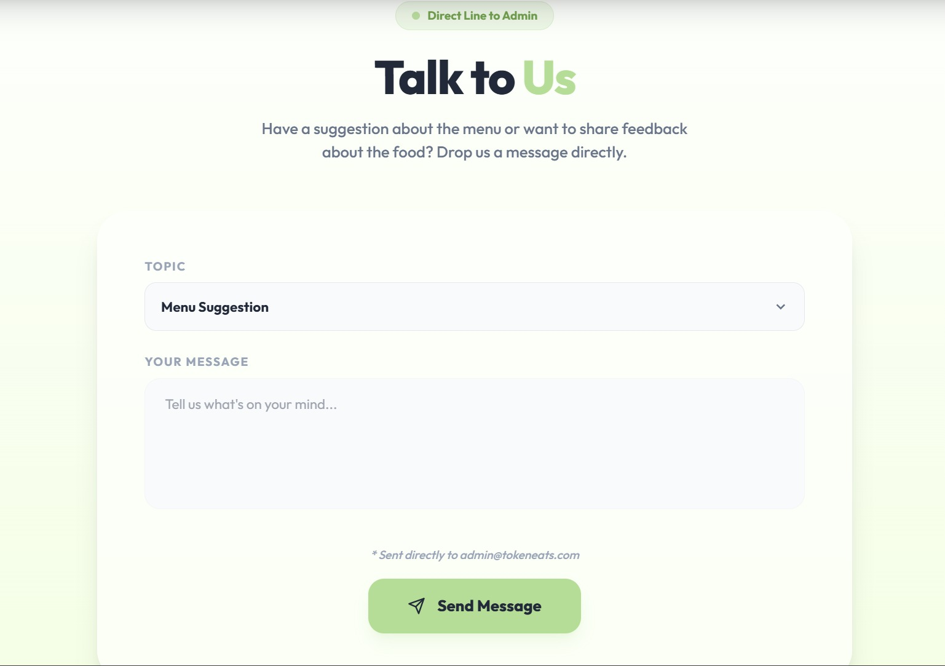

- Admin Hub
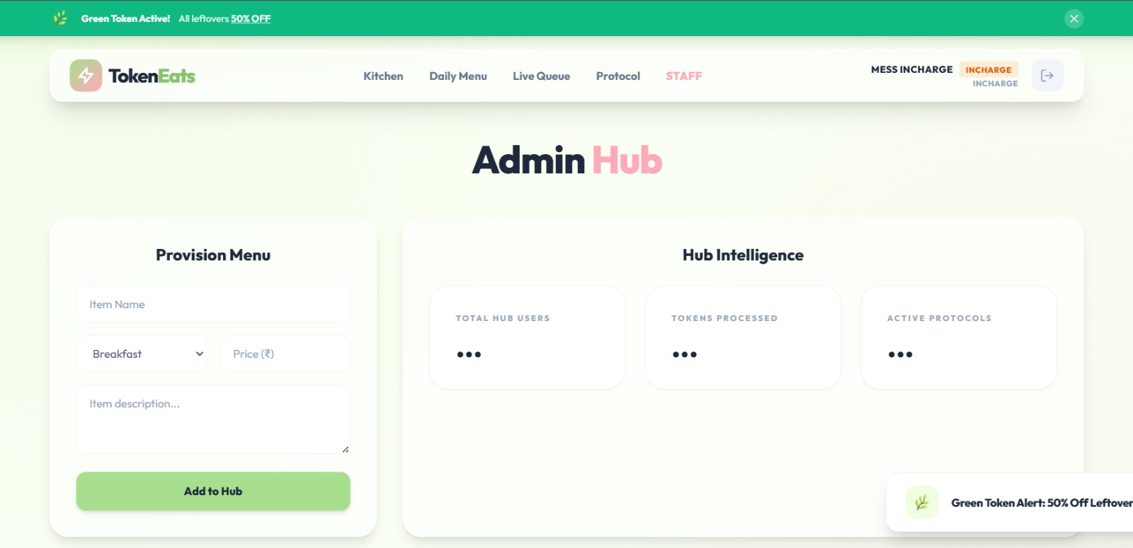

- Waste Intelligence
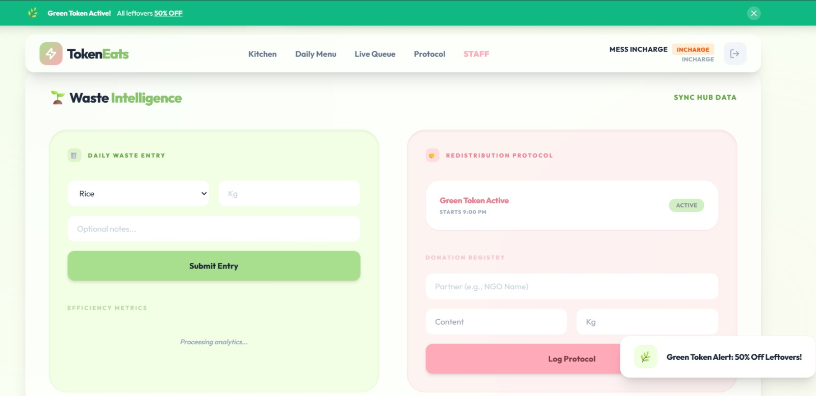

- Footer
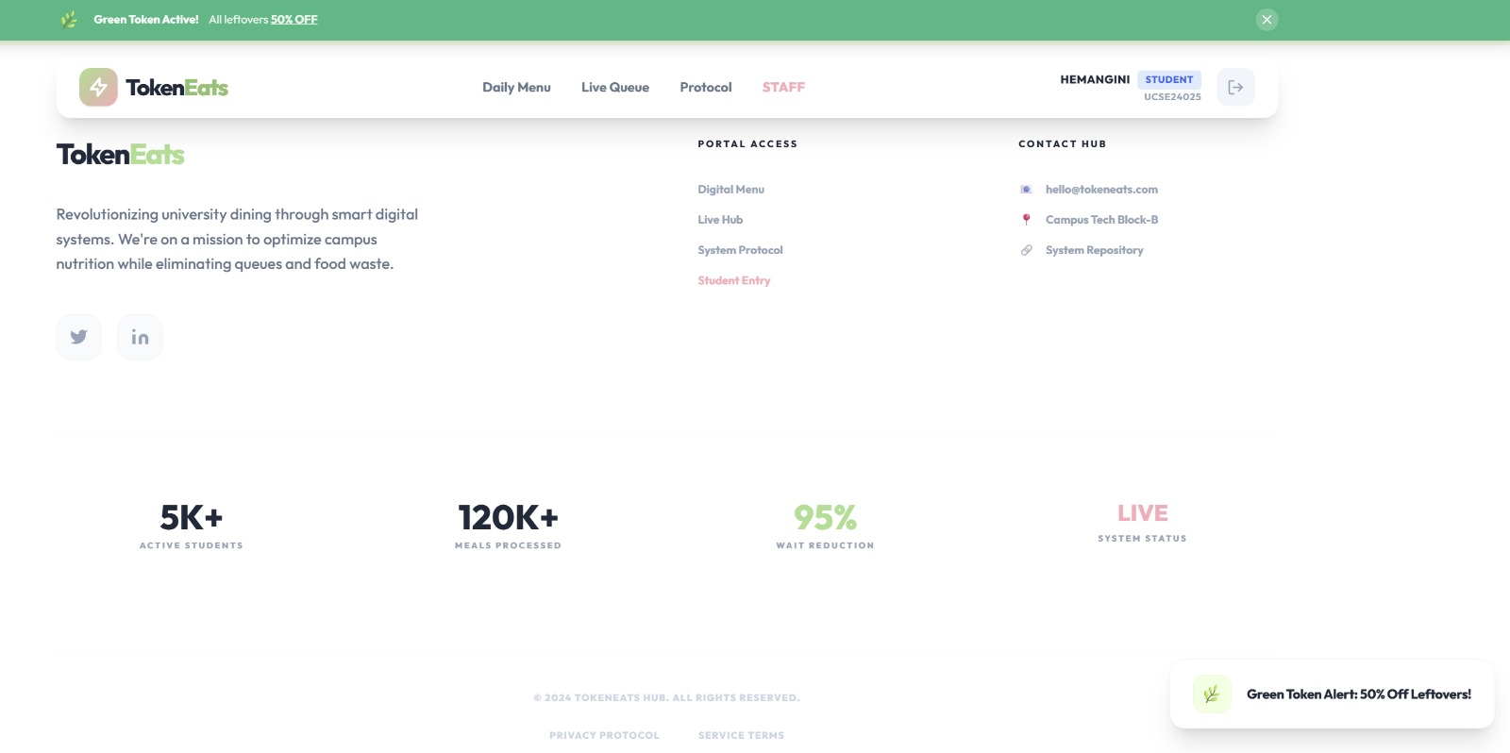

2. Observed Results
After implementing the system, the following improvements were observed:
- Reduced waiting time during peak hours.
- More organized and regulated entry process.
- Accurate estimation of food preparation.
- Reduced food wastage due to demand-based planning.
- Improved transparency in attendance monitoring.
- The system successfully ensures that each token is used only once, preventing duplication or misuse.

3. Performance Evaluation
The prototype was tested under multiple user scenarios:
- Multiple students generating tokens simultaneously.
- Re-scanning of already used tokens.
- Invalid token attempts.
- Real-time dashboard updates.
The system handled these scenarios efficiently without data inconsistency, proving reliability and robustness.

LIMITATIONS:

Internet Dependency
The TokenEats system relies on internet connectivity for real-time token generation and validation. In case of network failure or poor connectivity, token issuance and verification may be temporarily affected.
Hardware Constraints at Counters
Each serving counter requires a QR scanner or camera-enabled device. Lack of proper hardware may slow down adoption or increase initial setup cost.
Privacy Awareness Among Users
Some users may be hesitant to use digital systems due to concerns about data tracking and privacy.
Resistance to Change
Institutions accustomed to traditional methods may resist shifting to a fully digital mess management system.

CHALLENGES

&

FUTURE SCOPE:

1. Challenges Faced
During the development and conceptualization of TokenEats, several challenges were identified:
a) Real-Time Data Handling
Ensuring that token generation and QR validation update instantly without delay required proper backend synchronization and database handling.
b) Network Dependency
Since the system operates online, stable internet connectivity is essential. Poor network conditions could affect real-time verification.
c) User Adaptability
Transitioning from a traditional manual system to a digital platform may initially face resistance from users who are unfamiliar with technology.

d) Security Concerns
Ensuring that tokens cannot be duplicated or misused required secure authentication and unique ID generation mechanisms.
Despite these challenges, proper system design and structured implementation help overcome these limitations.

2. Future Scope
The TokenEats system can be further enhanced with additional advanced features:
- Mobile Application Development for easier accessibility.
- AI-Based Demand Prediction to forecast meal requirements based on historical data.
- Integration with RFID/Smart ID Cards for faster authentication.
- Multi-Campus Deployment for universities with multiple hostels.
- Online Payment Integration for paid meal systems.
- Notification System to remind students about meal timings or token generation windows.
- With these improvements, TokenEats can evolve into a complete smart campus dining solution.

CONCLUSION:
TokenEats presents a modern and efficient approach to solving the common problems associated with traditional mess management systems. By introducing digital tokenization, QR-based verification, and real-time monitoring, the system significantly reduces overcrowding, waiting time, and food wastage.
The project demonstrates how technology can be effectively applied to improve everyday campus operations. It not only enhances the dining experience for students but also provides management with accurate data for better decision-making.
Overall, TokenEats is a scalable, secure, and sustainable solution that aligns with the vision of smart and digitally empowered campuses. The successful implementation of this system highlights the potential of technology-driven solutions in improving institutional infrastructure and operational efficiency.

